WORKSHEET 3.3

Student Name: Ravi Shankar Singh UID: 21BCS11619

Branch: CSE Section/Group: 808-B

Semester: 4th Date of Performance:

Subject Name: Programming in Python Lab Subject Code: 21CSP-259

**Aim:**

**Program to demonstrate read and write data to the file in various modes.**

1. **Write a Python program to generate 26 text files named A.txt, B.txt, and so on up to Z.txt**

**Source Code:**

import string, os

if not os.path.exists("letters"):

os.makedirs("letters")

for letter in string.ascii_uppercase:

with open(letter + ".txt", "w") as f:

f.writelines(letter)

**OUTPUT:**

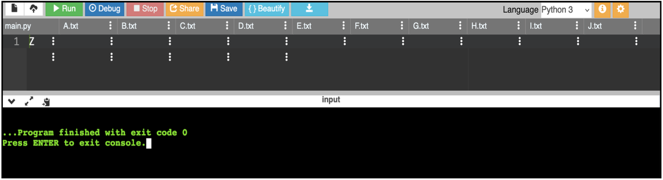

1. **Write a Python program to create a file where all letters of English alphabet are listed by specified number of letters on each line .**

**Source Code:**

import string

def letters_file_line(n):

with open("words1.txt", "w") as f:

alphabet = string.ascii_uppercase

letters = [alphabet[i:i + n] + "\n" for i in range(0, len(alphabet), n)]

f.writelines(letters)

letters_file_line(3)

# **OUTPUT:**

# 

1. **Write a Python program to read a random line from a file.**

**Source Code:**

import random

def random_line(fname):

lines = open(fname).read().splitlines()

return random.choice(lines)

print(random_line('Myfile.txt'))

**OUTPUT:**

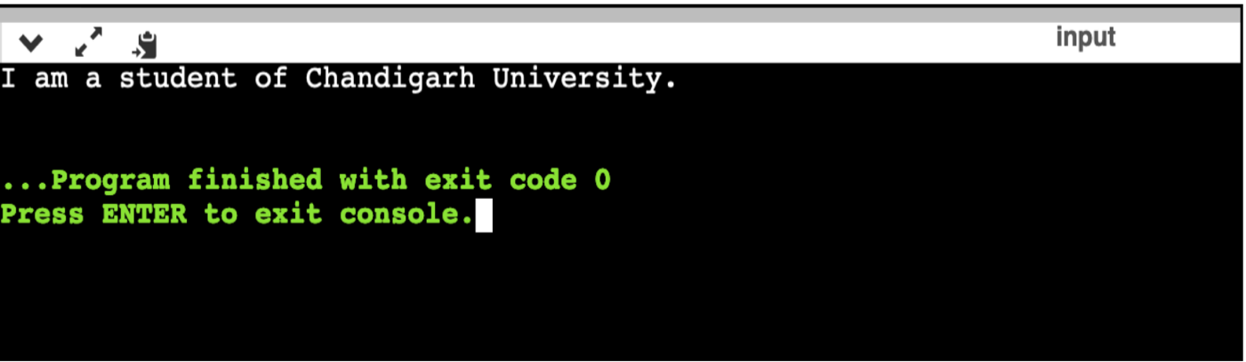

1. **Write a Python program to count the frequency of words in a file.**

**Source Code:**

from collections import Counter

def word_count(fname):

with open(fname) as f:

return Counter(f.read().split())

print("Number of words in the given file :\n",word_count("Myfile.txt"))

**OUTPUT:**

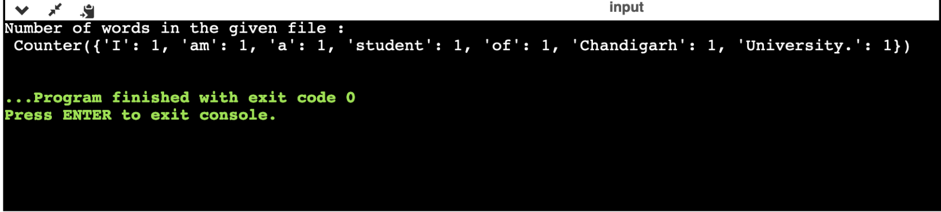

1. **Write a Python program to copy the contents of a file to another file.**

**Source Code:**

with open('Myfile.txt','r') as firstfile, open('This.txt','a') as secondfile:

for line in firstfile:

secondfile.write(line)

print("text copied from one file to another successfully")

**OUTPUT:**

